# Github Project Workflow

1. Go to the Project GitHub Repository
   1. <https://github.com/khnguyen88/GVSU-CIS641-Lakeshore-Misfits>

## Github Project

1. Click on the **Project** tab on the Project Repository’s Navigation Bar
   1. 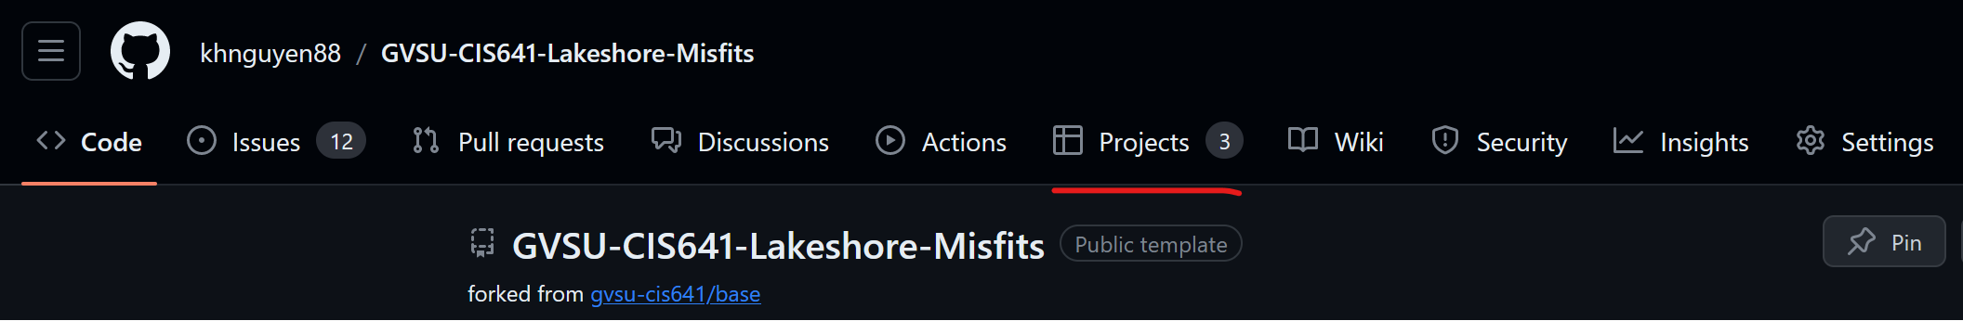
2. Click on the current sprint
   1. 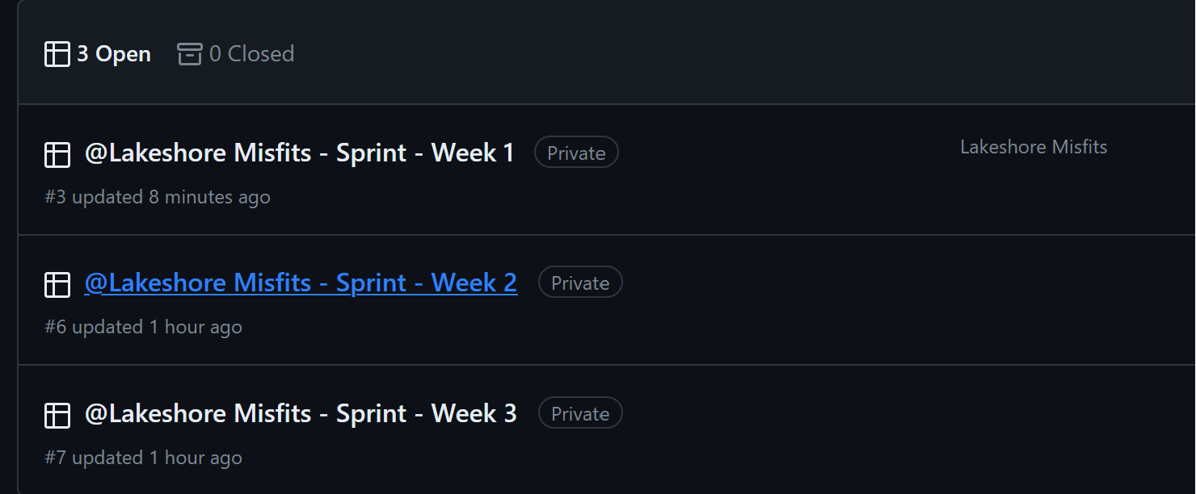
3. You will see multiple views of the tasks we have on hand
   1. View 1: List View
      1. Decent too!
   2. View 2: Board View
      1. Recommended
   3. View 3: Gantt Chart View
      1. We are not using this!!
4. Find the task assigned to you and change the status
   1. **View 1:** Click on the Status dropdown and change it from **Todo** to **In Progress**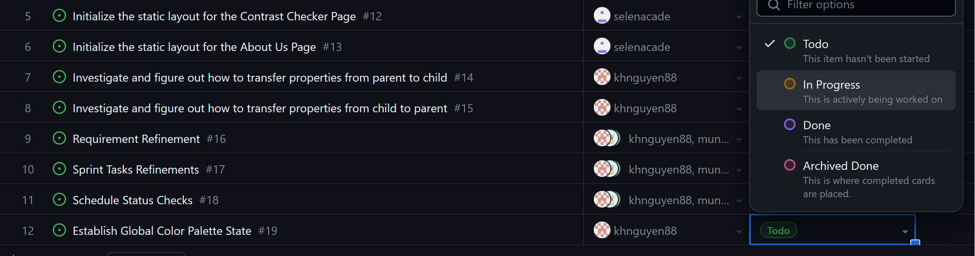
   2. **View 2:** Drag and drop your task from the **Todo** section into the **In Progress Section  
      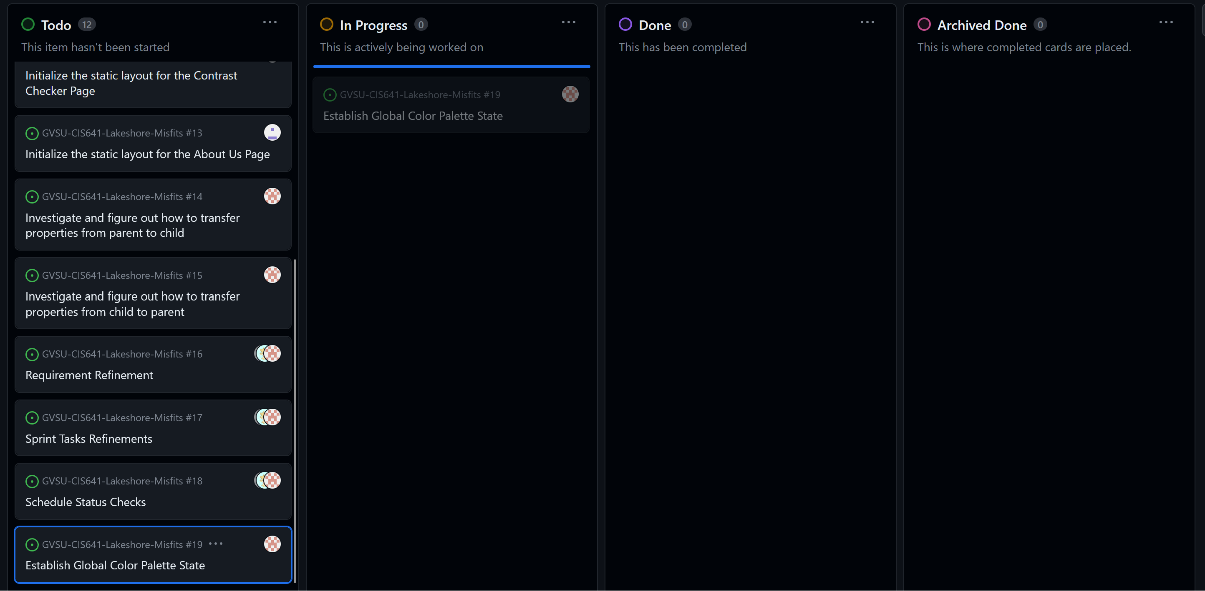**
5. Task Status Notes
   1. **ToDo** – The task is assigned to an engineer/dev but has yet to be worked on
   2. **In Progress** – The task is currently has been selected and worked on by a dev
   3. **Done** – The task has been completed and currently waiting to be reviewed, and the work branch is waiting to be merged into the main branch
   4. **Archived Done** – The task has reviewed and merged into the main branch
6. Select on the task/issue to go to it’s issue page:
   1. 
   2. 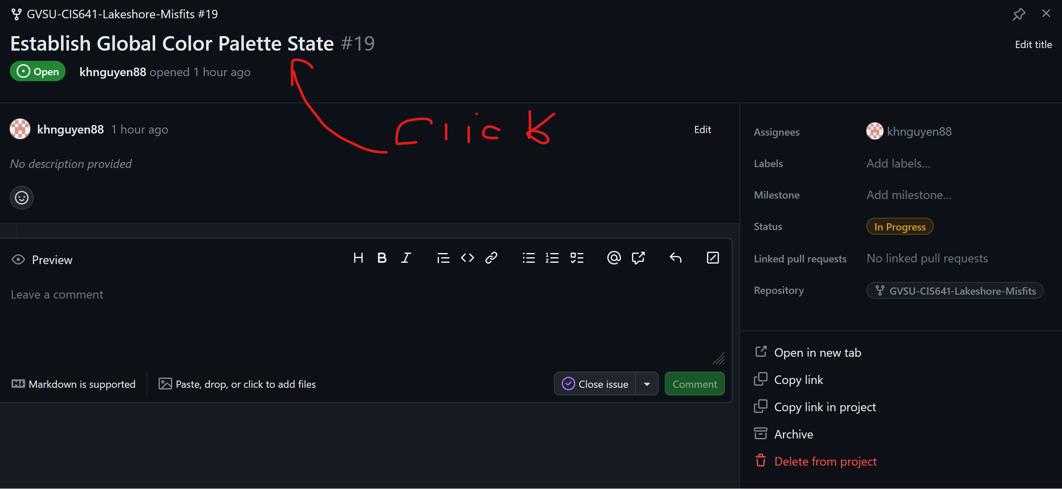

## GitHub Issue

1. After we click on the issue assign to use and are in the issue page
   1. Alternatively we can go into our Project Issue tab and select the Issue/Task we want to comment on and close
2. We want to create a work branch that is **separate from our main branch**
3. In the task/issue page, click on the **“Create a branch”** link on the right side bar, under the Development header:
   1. 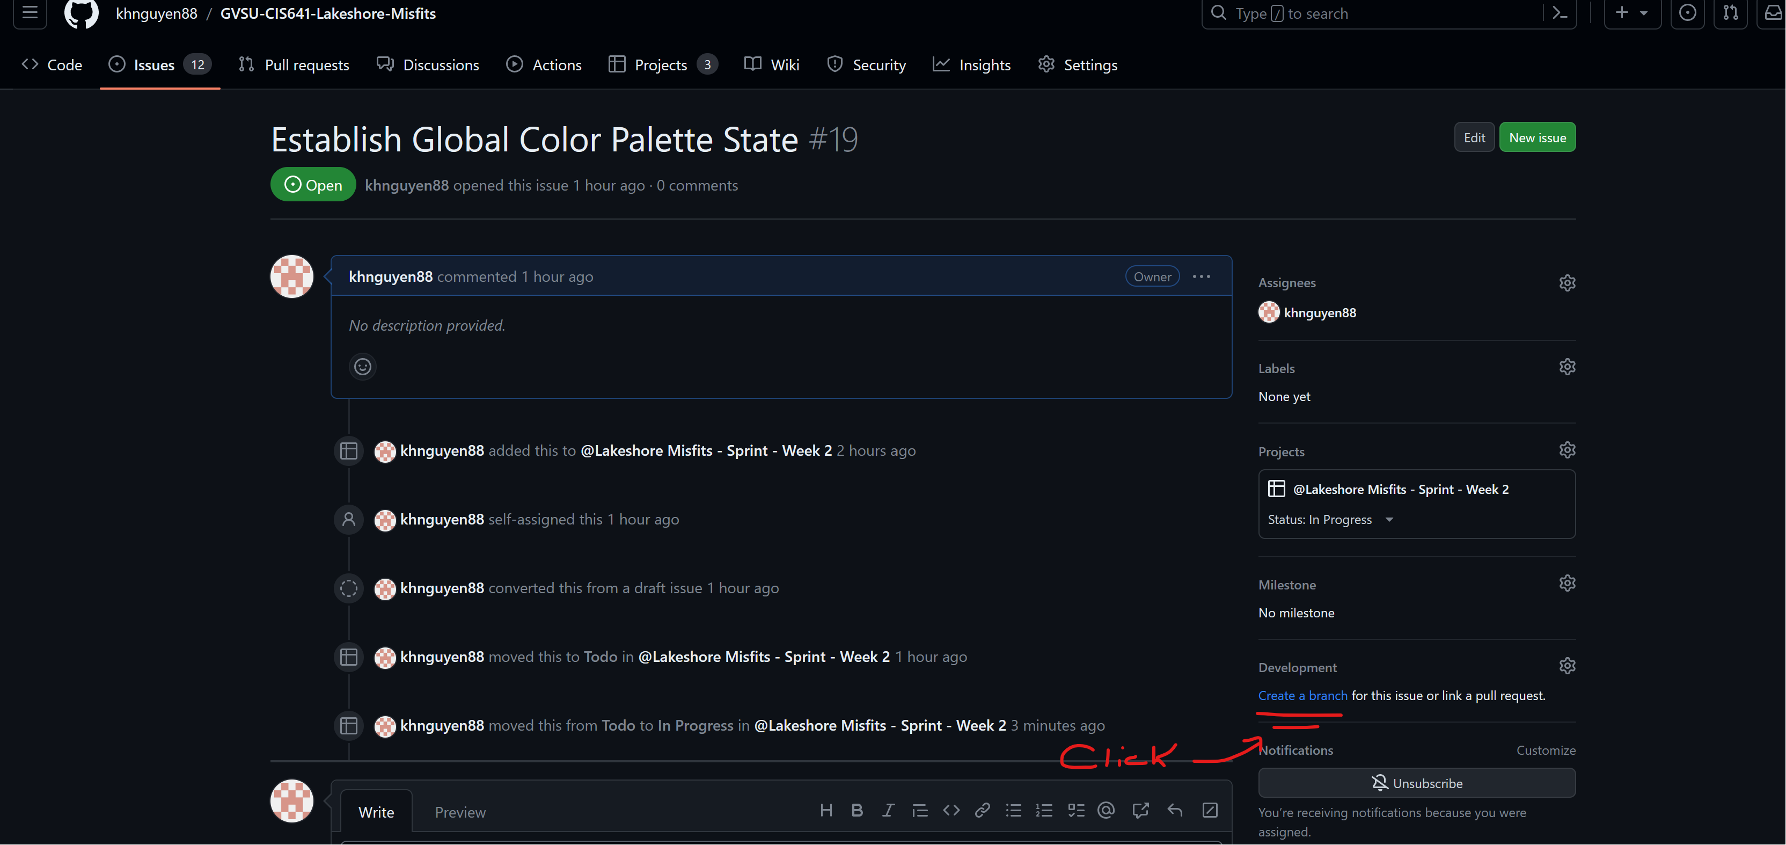
4. Create a new branch for the particular issue and set to **checkout locally**!!
   1. 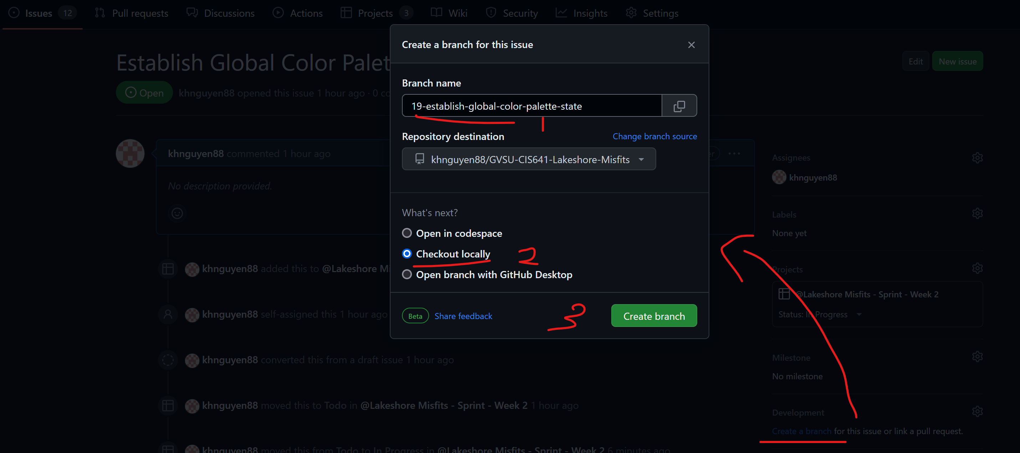
5. Copy the following command to our local clone in the VS Code Terminal
   1. 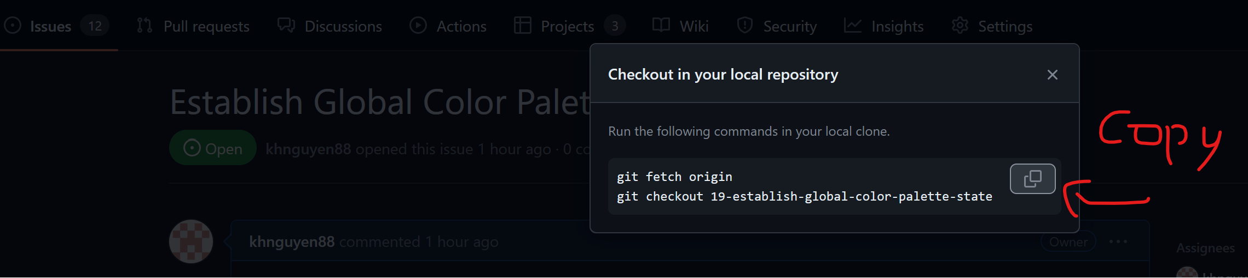
6. Paste the commands into the VS Code terminal while we our in Project Folder in VS Code:
   1. 
7. We now fetched the new branch into our local repository and checked it out
   1. 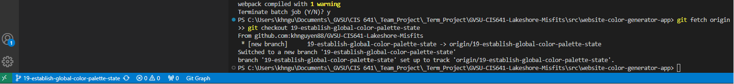
8. Make the necessary changes desired and then once we are done. Press the “**close with comments**” button to close the issue with comments
   1. 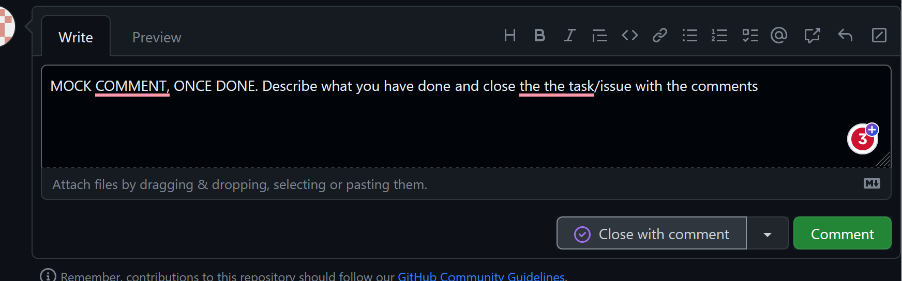

## GitHub Pull Request

1. After We Closed Our Issues, We need to go into the **Pull Requests** tab
   1. 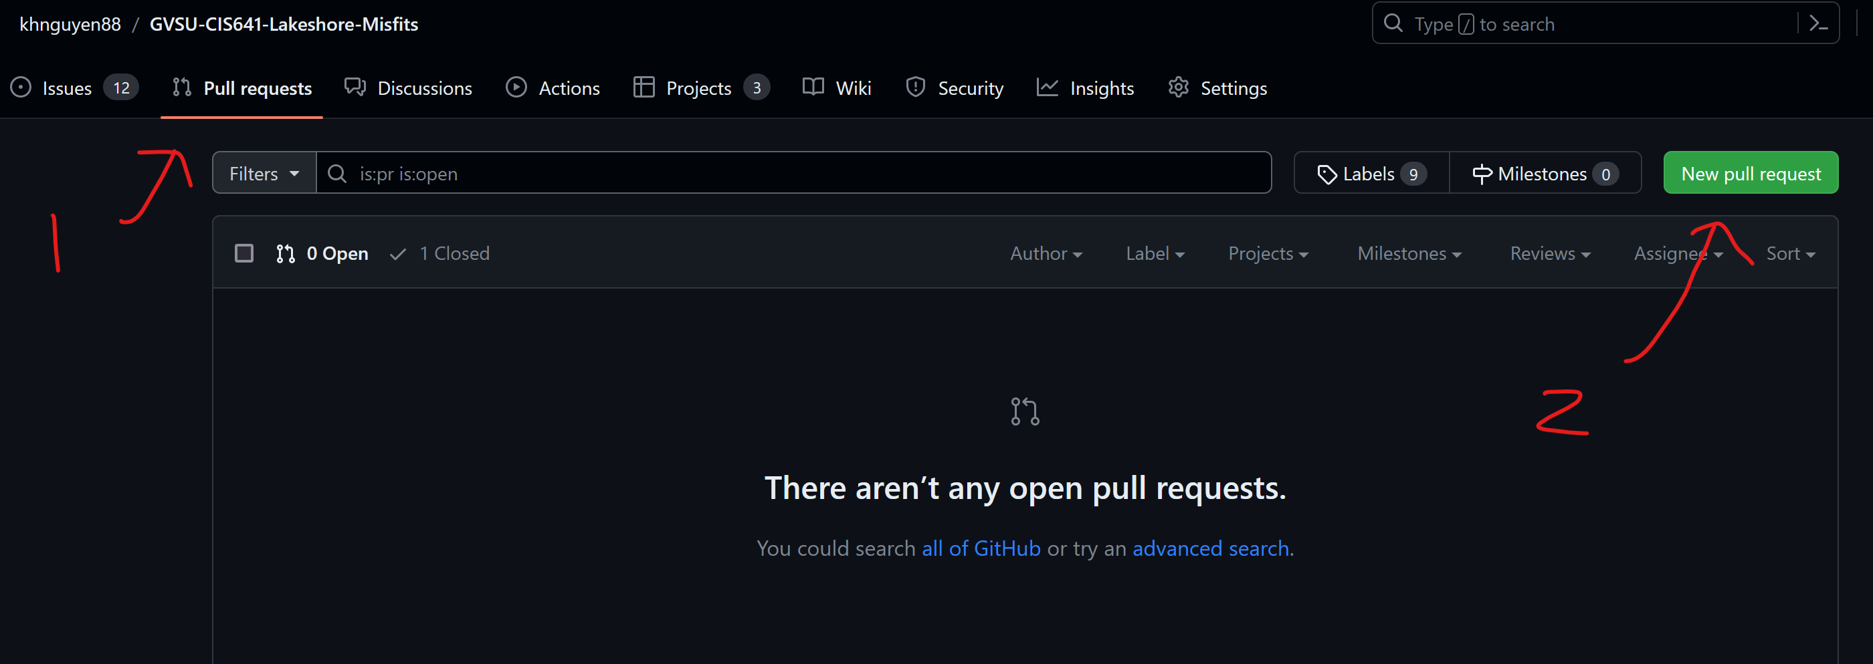
2. After we click on the pull request button, we need to determine which branches we want to compare and what we want to merge into.  
   1. It is always “Parent (Main) Branch” (Left Side) 🡨”Child (Working) Branch (Right Side)
      1. We are comparing the Child branch to the Main Branch
      2. We want to merge the Chil branch into the Main Branch
   2. **NOTE, VERY IMPORTANT!! MAKE SURE WE SET THE BASE REPOSITORY FOR BOTH BRANCH CORRECTLY!! SET TO TEAM PROJECT REPOSITORY AND NOT THE BASE REPOSITORY WE FORKED FROM.**
   3. 